Mary’s cat “Honey” was lost for two days about three months ago. She now has four kittens (see **Photo 1**). Mary wants to know if the two neighboring cats could be the father: Tom in **Photo 2**, or Butch in **Photo 3**. It is known that the same litter of kittens can have multiple fathers – it may be possible that every single kitten in the litter has a different father!

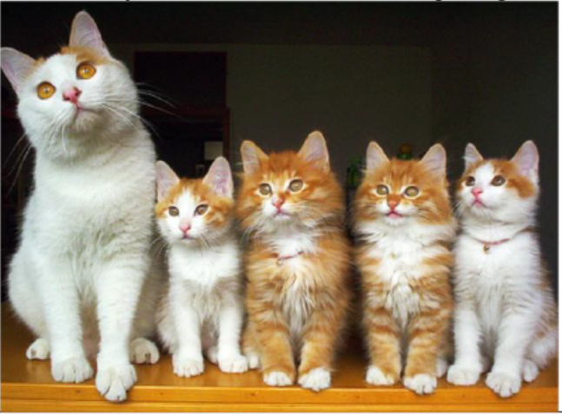**Photo 1:** From left to right: Honey (Mom), Molasses, Cream, Ginger, and Sugar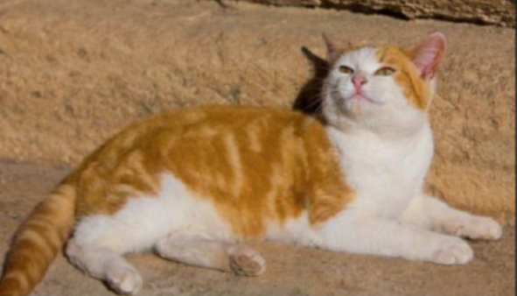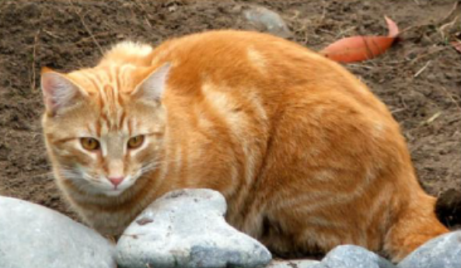

**Photo 2:** Tom (Dad #1) **Photo 3:** Butch (Dad #2)

To analyze their DNA fingerprints, Mary has collected hair follicles from each adult cat and kitten, extracted DNA, and amplified their DNA using ploymerase chain reaction (PCR).

You will be running agarose gel electrophoresis these “DNA” samples to determine the genetic father of each kitten.

HYPOTHESIS:

**Table 1: Phenotype Prediction**: Looking at the photos, who might be the father of each kitten?

| KITTEN | POTENTIAL DAD | EXPLAIN REASONING |
| --- | --- | --- |
| 1: Molasses |  |  |
| 2: Cream |  |  |
| 3: Ginger |  |  |
| 4: Sugar |  |  |

PROCEDURE:

NOTE: The following is completed when the electrophoresis chamber has been prepared with an 0.8% agarose gel and 1x TBE buffer in the chamber.

1. Obtain the "DNA samples" - there are seven microfuge tubes labeled P- V.
2. Centrifuge all tubes for 5-10 seconds.
3. Using a P-20 pipette *with a* tip, load 5µL of sample P into the second well. Leave the first well blank.
4. Using new tips each time, continue to load 5µL of each sample in the order listed in **Table 2** below.
5. Be sure to keep track of your sample loading, if you do not follow the table below. If there were any problems with loading the wells (punctured gel, not enough sample), record it in the NOTES column.

**Table 2: Gel Loading Order**

| Well | Tube | DNA Sample | NOTES (problems, loss of samples, etc) |
| --- | --- | --- | --- |
| 2 | P | Tom (Dad #1) |  |
| 3 | Q | Molasses (Kitten #1) |  |
| 4 | R | Cream (Kitten #2) |  |
| 5 | S | Honey (Mom) |  |
| 6 | T | Ginger (Kitten #2) |  |
| 7 | U | Sugar (Kitten #4) |  |
| 8 | V | Butch (Dad #2) |  |

Run the gel for 20-25 minutes. Check every 5 minutes starting at the 15-minute mark to preserve your results. This is to prevent loss of data if the gel should run too long.

ANALYSIS:

Record the band patterns in **Table 3** below.

**Table 3: DNA banding results**

| **Tube** | **P** | **Q** | **R** | **S** | **T** | **U** | **V** |
| --- | --- | --- | --- | --- | --- | --- | --- |
| **Colour**  **Band** | **Tom**  **Dad #1** | **Cream**  **Kitten 1** | **Molasses**  **Kitten 2** | **Honey**  **Mom** | **Ginger**  **Kitten 3** | **Sugar**  **Kitten 4** | **Butch**  **Dad #2** |
| **Blue** |  |  |  |  |  |  |  |
| **Blue**  **Pink** |  |  |  |  |  |  |  |
| **Orange** |  |  |  |  |  |  |  |
| **Yellow** |  |  |  |  |  |  |  |

1. Carefully consider each band of both kitten samples and determine whether the band matches Tom, Honey or Butch. For the Kitten samples (K1/K2) in the Data Table, write (on top of the coloured blocks) who each band matches Tom, Honey, Butch.

2. Draw your conclusions based on the DNA evidence. Who was the father for each kitten based on looking at the kitten? Who is the father based on the DNA evidence? What is the specific evidence that justifies your claim for determining each kitten’s father? Fill your responses to these questions in **Table 4**.

**Table 4: Paternity Assignment and Justification**

| **Kitten** | **Father based on Visual** | **Father based on DNA** | **Justification/Rationale** |
| --- | --- | --- | --- |
| Cream  Kitten 1 |  |  |  |
| Molasses  Kitten 2 |  |  |  |
| Ginger  Kitten 3 |  |  |  |
| Sugar  Kitten 4 |  |  |  |

Answer key

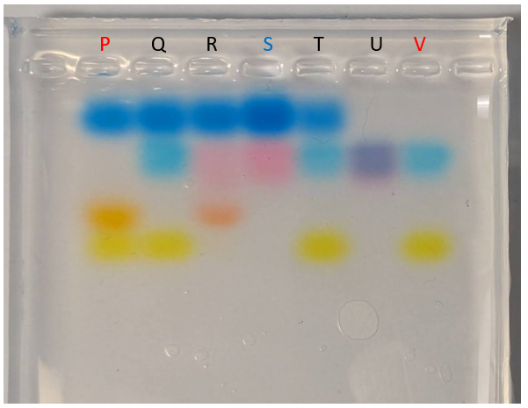

| **Tube** | **P** | **Q** | **R** | **S** | **T** | **U** | **V** |  |
| --- | --- | --- | --- | --- | --- | --- | --- | --- |
|  | **Tom**  **(Male)** | **Cream** | **Molasses** | **Honey**  **(Female)** | **Ginger** | **Sugar** | **Butch**  **(Male)** |  |
| **Blue** | Blue | Blue | Blue | Blue | Blue |  |  |  |
| **Blue** |  | Blue |  |  | Blue | Blue | Blue | These run at the same location |
| **Pink** |  |  | Pink | Pink |  | Pink |  |
| **Orange** | Orange |  | Orange |  |  |  |  |  |
| **Yellow** | Yellow | Yellow |  |  | Yellow |  | Yellow |  |
| **Father** | --- | Butch | Tom | --- | Butch | Butch | --- |  |

Extension answers of any other patterns:

Cream + Ginger are twins - same banding pattern

Cream + Ginger may be boys - same yellow band as Tom and Butch

Molasses and Sugar may be girls - same pink band from Honey