

**Student Laboratory Workbook**

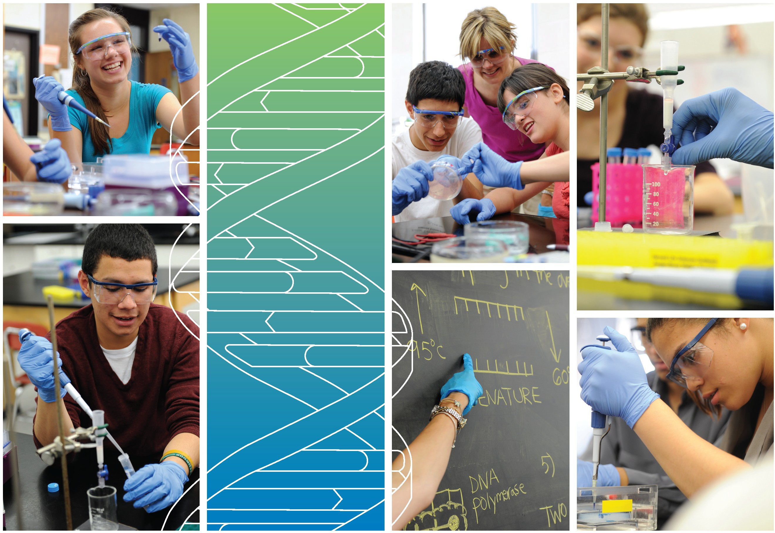





[**www.amgenbiotechexperience.com**](http://www.amgenbiotechexperience.com/)

AmGen biotech experience Laboratory Workbook

HSC biology stage 6 syllabus links

Conducting Investigations

Students are to select appropriate equipment, employ safe work practices and ensure that risk assessments are conducted and followed. Appropriate technologies are to be used and procedures followed when disposing of waste.

Outcomes

A student:   
conducts investigations to collect valid and reliable primary and secondary data and information BIO11/12-3

Content

Students:

* employ and evaluate safe work practices and manage risks (ACSBL031) Personal and social capability icon Work and enterprise icon
* use appropriate technologies to ensure and evaluate accuracy  Information and communication technology capability icon Numeracy icon

Modules where this material is relevant:

Module 5: Heredity

explains the structures of DNA and analyses the mechanisms of inheritance and how processes of reproduction ensure continuity of species BIO12-12

Module 6: Genetic Change

explains natural genetic change and the use of genetic technologies to induce genetic change BIO12-13

**Inquiry question:** How do genetic techniques affect Earth’s biodiversity?

Students:

* investigate the uses and applications of biotechnology (past, present and future), including: (ACSBL087)
  + analysing the social implications and ethical uses of biotechnology, including plant and animal examples  



* + researching future directions of the use of biotechnology  
  + evaluating the potential benefits for society of research using genetic technologies   
  + evaluating the changes to the Earth’s biodiversity due to genetic techniques   

**Genetic Technologies**

**Inquiry question:** Does artificial manipulation of DNA have the potential to change populations forever?

Students:

* investigate the uses and advantages of current genetic technologies that induce genetic change
* compare the processes and outcomes of reproductive technologies, including but not limited to:
  + artificial insemination
  + artificial pollination
* investigate and assess the effectiveness of cloning, including but not limited to:  
  + whole organism cloning
  + gene cloning
* describe techniques and applications used in recombinant DNA technology, for example:  
  + the development of transgenic organisms in agricultural and medical applications (ACSBL087)
* evaluate the benefits of using genetic technologies in agricultural, medical and industrial applications (ACSBL086)  
* evaluate the effect on biodiversity of using biotechnology in agriculture 
* interpret a range of secondary sources to assess the influence of social, economic and cultural contexts on a range of biotechnologies  



Module 7: Infectious Disease

**Prevention, Treatment and Control**

**Inquiry question:** How can the spread of infectious diseases be controlled?

Students:

* investigate procedures that can be employed to prevent the spread of disease, including but not limited to: (ACSBL124)

– hygiene practices

– quarantine

– vaccination, including passive and active immunity (ACSBL100, ACSBL123) (these are now   
 developed using genetic engineering)

– public health campaigns

– use of pesticides

– genetic engineering

Module 8: Non-infectious Disease and Disorders

**Prevention**

**Inquiry question:** How can non-infectious diseases be prevented?

Students:

* use secondary sources to evaluate the effectiveness of current disease-prevention methods and develop strategies for the prevention of a non-infectious disease, including but not limited to: 

– educational programs and campaigns Personal and social capability icon

– genetic engineering 

laboratory 1.1: P20 Pipette Practice

Draw the settings on the pipette for:

|  |  |  |  |
| --- | --- | --- | --- |
| 20 µL | 12.4 µL | 5.5 µL | 2.0 µL |
|  |  |  |  |

A diagram showing the laminated P20 practice sheet.

Insert your photo in here

How to pipette (order the actions)

|  |  |
| --- | --- |
| **Mixed order** | **Correct order (just write the numbers down)** |
| 1. Push the plunger down to the first stop |  |
| 1. Push the plunger all the way to the bottom |  |
| 1. Set the volume you need to deliver |  |
| 1. Put the pipette (with tip on) into the solution you want to deliver |  |
| 1. Put the correct tip on |  |
| 1. Release the plunger and allow the solution to suck up into the tip |  |
| 1. Touch the side of the tube/surface you want to deliver the solution to |  |

laboratory 1.1 continued: P200 Pipette Practice

Draw the settings on the pipette for:

|  |  |  |  |
| --- | --- | --- | --- |
| 200 µL | 137µL | 48 µL | 25 µL |
|  |  |  |  |

A diagram showing the laminated P200 practice sheet.

Insert your photo here:

1. What volume would the following pipette settings deliver?

|  |  |  |  |  |  |  |  |  |  |  |
| --- | --- | --- | --- | --- | --- | --- | --- | --- | --- | --- |
| P20 |  | P200 |  | P20 |  | P200 |  | P20 |  | P200 |
| 0 |  | 0 |  | 1 |  | 1 |  | 2 |  | 0 |
| 7 |  | 7 |  | 0 |  | 0 |  | 0 |  | 2 |
| 5 |  | 5 |  | 0 |  | 0 |  | 0 |  | 0 |

1. What settings would you use to deliver 25 µL using a P200 and a P20? *Hint you might have to pipette more than once to deliver the volume with one of the pipettes.*

P200:

P20:

1. Fill in the table below with the ranges and settings for each of the pipettes you will be using in this program.

|  |  |  |  |  |
| --- | --- | --- | --- | --- |
| **Type of pipette** | **Volume range** | | **Tip** | **Settings used** |
| (ml) | (µl) |
| P20 |  |  |  |  |
| P200 |  |  |  |  |
| P1000 |  |  |  |  |

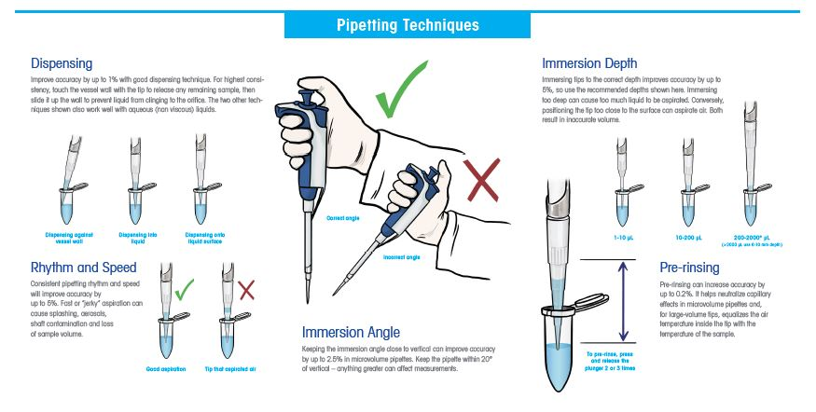

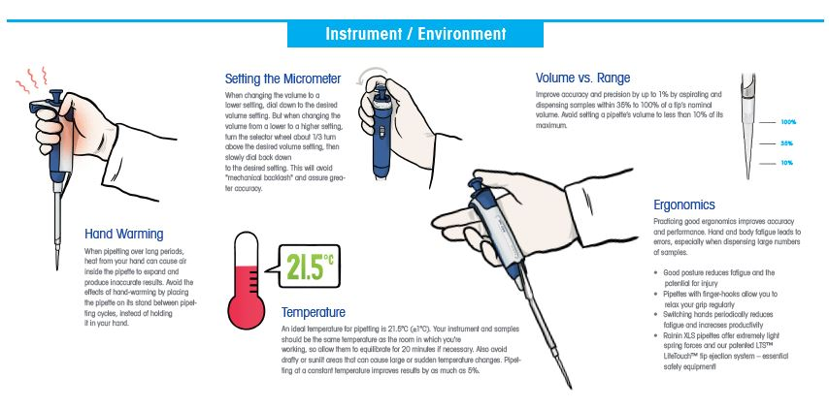https://www.mt.com/us/en/home/library/know-how/rainin-pipettes/rainin-pipetting-techniques-poster.html

laboratory 1.2: Gel Electrophoresis Practice

Here is a schematic of your agarose gel. Annotate (that means mark) the polarity (charge) and the loading order. Draw in where the bands were when the gel finished.

The dyes you are separating are orange G (yellow), bromophenol blue (purple) and xylene cyanol (blue)

1. Based on the results of the gel, which solution (S1, S2 or S3) contained a single dye?
2. Based on the results of the gel, what charge are dyes in solutions S1, S2 and S3?
3. If all three dyes have a similar shape and charge which dye has the smallest molecular weight?

Go onto the internet and search for an image of the three dyes on an agarose gel. Does your image agree with the internet image?

chapter 2A: How do you begin to clone a gene?

What do you already know?

1. The structure of DNA. Consider the following questions:

* What is the backbone composed of?
* Where is the information stored? How is this information protected from the cell’s chemicals?

1. Most living things use DNA as their store of genetic information. In what ways is DNA from different organisms the same, and in what ways does it vary?
2. Using your understanding of genes and how they are expressed, explain why it is possible for a bacterial cell to make a human protein from the instructions encoded in a human gene.
3. As described in the Amgen Biotech Experience Program Introduction, scientists use two biological tools to engineer organisms to make new proteins: plasmids and restriction enzymes. What do you remember about how these tools are used?

plasmids

1. What are plasmids?
2. What are the features of an ideal plasmid used for cloning? Why would these features be included in cloning plasmids?
3. How will ampicillin be used in subsequent experiments?
4. How are plasmids used in genetic engineering?

Restriction enzymes

1. What are restriction enzymes?
2. What is a recognition site?
3. What is the difference between sticky ends and blunt ends? How is this achieved?
4. How do bacteria protect their own DNA when “restricting” foreign DNA?

Cloning

1. What is cloning?
2. When selecting which restriction enzyme(s) to use what must you consider?

Laboratory 2A: Preparing to verify the *RFP* gene: digesting the pARA-R plasmid

**After the paper exercise answer the following questions before the lab:**

1. What are the advantages of using two restriction enzymes?
2. What does the ampicillin resistance gene code for? Why is it included in the plasmid?
3. What is the promoter region? What does it do?
4. What is *araC* and why might this be included in the plasmid?

Setting up the restriction digests







R-



R+

1. 4.0 µL 2.5xB (buffer)

2. 4.0 µL RP (plasmid)

3. 2.0 µL RE (enzymes)

**Total volume = 10 µL**

1. 4.0 µL 2.5xB (buffer)

2. 4.0 µL RP (plasmid)

3. 2.0 µL H2O

**Total volume = 10 µL**

1. Make sure both tubes are clearly labelled with a waterproof marking pen on the lids and sides of the tubes.
2. Mix both tubes well by sucking up and down with a pipette set to ~5 µL. *This way you   
   don’t introduce bubbles which can denature the restriction enzymes*.
3. You may need to give the tubes a quick spin for a few seconds in a centrifuge to bring the drops to the bottom of the tubes. Make sure you balance the tubes when doing any centrifuging.
4. Your tubes are now ready to be incubated at 37oC to allow the enzymes to digest the plasmid DNA. Place the tubes in a floating microfuge rack and then place the rack in the water bath.
5. You will need to leave the tubes there for at least 60 minutes.
6. After that, store at -20oC. The success of the digest will be checked in the next lab session.

Some questions about the experimental set up

1. What is the purpose of the **R-** tube?
2. Can you think of any other controls you might set up?

Discussion questions from the student guide

1. What roles do restriction enzymes have in nature?
2. Why do bacteria retain a gene that codes for antibiotic resistance? Does this have implications for medicine?
3. Explain how human genes can be expressed in bacteria to make a product never before made by the bacteria.
4. Bacteria carrying a plasmid which contains the gene for ampicillin resistance have been mixed accidently with bacteria carrying a plasmid with kanamycin resistance. Design an experiment to separate the two kinds of bacteria.

Laboratory 4A: Verification of the recombinant plasmid using gel electrophoresis

**Answer the following questions before the lab:**

1. If the pARA-R plasmid was digested with BamHI and HindIII how many fragments would you generate? What would you predict the sizes to be? What type of ends would result (sticky or blunt)? Use the diagram on page 46 of the student guide here.
2. If one of the restriction enzymes was not working, what product(s) would you expect to see?
3. Agarose gel electrophoresis separates DNA fragments by size (page 60 in the student guide). How does it do this? Have a look on page 60 for a brief description.
4. Predict what your gel would look like based on a complete digest with both enzymes (R+), no enzymes (R-) and if only one enzyme digested pARA-R.
5. Write the sizes of the fragments and highlight which sequences are contained in each fragment in the table below.

|  |  |  |  |
| --- | --- | --- | --- |
| **Digest tube** | **Enzymes** | **Fragment size in bp (and kbp) predicted** | **Sequences contained** (highlight those in the fragment) |
| R- | none |  | araC pBAD rfp ampR ori |
|  | araC pBAD rfp ampR ori |
|  | araC pBAD rfp ampR ori |
| R+ | BamHI and HindIII |  | araC pBAD rfp ampR ori |
|  | araC pBAD rfp ampR ori |
|  | araC pBAD rfp ampR ori |
| One enzyme | BamHI or HindIII |  | araC pBAD rfp ampR ori |
|  | araC pBAD rfp ampR ori |

DNA ladder

R-

R+

One enzyme

10,000

8,000

6,000

5,000

4,000

500

1,000

1,500

2,000

3,000

DNA Fragment size (bp)

**Once the gel is loaded:**

Write down your gel loading order from left to right:

**After the gel has run:**

Insert your gel image here:

**Annotate the gel image:**

This will include the polarity (the + and – ends), the loading order, the size of the DNA ladder standards and label each band, either numbering or Roman numerals. This way you can unambiguously refer to the bands in the table following.

* Compare the predicted sizes with the observed sizes (in kbp) in the table below:

|  |  |  |  |  |  |  |
| --- | --- | --- | --- | --- | --- | --- |
| **Fragment** | **R- (no enzymes)** | | **R+ (two enzymes)** | | **One enzyme** | |
|  | Predicted | Observed | Predicted | Observed | Predicted | Observed |
|  |  |  |  |  |  |  |
|  |  |  |  |  |  |  |
|  |  |  |  |  |  |  |
|  |  |  |  |  |  |  |
|  |  |  |  |  |  |  |

Chapter 4A Questions

1. Why is it important to verify you have the correct recombinant plasmid?
2. Did you see any bands you did not expect? How could you explain these?
3. Do you have the correct recombinant plasmid? Justify your answer.
4. In the R+ lane do you see evidence of incomplete digestion? Explain your answer.
5. Does the configuration of the DNA (linear, supercoiled circular, nicked circle) affect the migration in the gel? Explain your answer from your results.
6. Explain how you could end up with no bands.
7. Did you see any strange-shaped bands? Explain.
8. What would the gel look like if neither restriction enzyme worked?

chapter 5A: Getting Recombinant Plasmids into Bacteria

This section is particularly relevant to modules 5 and 6 in the HSC syllabus; Heredity and Genetic Change. Before we start investigations into how to get foreign DNA in the form of a plasmid into a bacterial cell we need to consider what you already know about plasmids and gene expression.

1. What are the steps when a cell transcribes and translates a gene (DNA) into the polypeptide (protein) it encodes? *This is essential for answering HSC exam questions.*
2. What is the relationship between genes (the genotype), proteins and traits (the phenotype)?
3. What do humans and bacteria (and for that matter all living organisms as well as a few non-living viruses) have in common that enables cloning?
4. Is the uptake by bacteria of plasmid DNA a common event? Why or why not? What structural features of bacteria make it difficult?

Terminology and abbreviations used in this lab session:

1. The CC tube contains 100 µL of competent cells. What are these?
2. What is the RP tube?
3. What is P+ and P-?
4. You will be given three plates: LB, LB/amp and LB/amp/ara. What are the differences between the three plates and what information will each component tell us?

**Read over the lab protocol before you start the lab and make sure you can answer the previous questions.**

Once you are confident with the terms and abbreviations, predict the bacterial growth on each of the plates. High growth will have lots of colonies, medium growth scattered colonies and no growth will be a blank plate.

|  |  |  |
| --- | --- | --- |
| **High growth**  Lots of colonies, often overlapping (+++) | **Medium or low growth**  Scattered colonies, usually discrete. Medium (++) or low (+) | **No growth**  Blank plate (-) |
|  |  |  |

|  |  |  |
| --- | --- | --- |
| **LB plate** | **LB/amp plate** | **LB/amp/ara plate** |
| **P-** | **P+**  **P-** | **P+**  **P-** | **P+** |  |  |
| Explain your prediction for each plate: | | |
| **P-** | **P-** | **P-** |
| **P+** | **P+** | **P+** |

laboratory 5A Protocol



**CC**: 100 µL competent cells



**P-** 50 µL competent cells with no plasmid added

**P+** 50 µL competent cells with 10 µL plasmid (RP) added

50 µL

50 µL

Keep these tubes on ice while you are dispensing

Add 10 µL plasmid (RP) to the 50 µL of competent cells

Ice for 15 minutes

Ice for 15 minutes

42oC for 45 seconds then ice at least 1 minute

42oC for 45 seconds then ice at least 1 minute

Add 150 µL LB and incubate at room temperature for 15 minutes

Add 150 µL LB and incubate at room temperature for 15 minutes

laboratory 5A Protocol continued

Once both your P- and P+ tubes have been prepared, you need to add 50 µL of the P- solution to each P- half of the plates and 50 µL of the P+ solution to each P+ half of the plates.



**P+**

|  |  |  |
| --- | --- | --- |
| **LB plate** | **LB/amp plate** | **LB/amp/ara plate** |
| **P-**  **P-** | **P+**  **P-** | **P+**  **P-** | **P+** |  |  |

Add 50 µL to each half plate and spread using the sterile spreader. The spreading technique will be shown to you.

Allow the plates to sit for ~5 minutes then parafilm the plates and incubate them upside down for 24 – 36 hours at 30oC.

CHAPTER 5A questions

1. Draw or insert an image of your plates after incubation below. Did the actual results agree with your predictions? If they didn’t, can you explain what might have happened? What would you change next time you did the experiment?
2. Did you get red colonies on any of the plates? If so which plate?
3. If the competent cells did not take up the plasmid what would the plates look like?
4. If you accidently contaminated the P- tube with plasmid what would the results look like?
5. You have a few colonies growing on the LB/amp P- side of the plate (nowhere near as many as the P+ side). How might you explain this observation?

Some BIG questions…

1. Why would the same bacterial culture appear red on one plate and not on another?
2. Would the red fluorescent protein (RFP) produced by the sea anemone (expressed from the *rfp* gene contained in the sea anemone’s genome) have the same amino acid sequence as the RFP produced by the recombinant bacteria containing the *rfp* gene? How is this possible?

Laboratory E: using PCR to amplify the *rfp* gene

**Class discussion before starting the laboratory**

1. When might it be important to copy DNA quickly? *There some very recent topical examples.*
2. How does PCR work?
3. Compare and contrast PCR with *in vivo* cloning (adding the genes to recombinant plasmids and transforming bacteria)
4. When would it be better to clone a gene *in vivo* and when might it be advantageous to copy the DNA by PCR?

Colony PCR in our laboratory project

We will be performing Colony PCR to confirm that our plasmid contains the *rfp* gene of interest. This is a much quicker way of gene confirmation than the plasmid isolation and restriction digestion performed in laboratory 2A. Your starting material will be white cells and red cells taken from LB/amp/ara plates. Both colonies will contain cells with a plasmid. *How do we know this?* Which plasmid will each colony contain?

Using the plasmid diagrams on page 95 of the student guide (Figure E.4) record the sizes of the amplified product (amplicon) expected using both pARA and pARA-R as templates.

|  |  |
| --- | --- |
| **Plasmid** | **Amplicon (bp)** |
| pARA |  |
| pARA-R |  |

Laboratory E Part a Protocol Flowchart

|  |  |  |  |  |  |
| --- | --- | --- | --- | --- | --- |
| **Component** | | **Tube 1**  **Red colony** | **Tube 2**  **White colony** | **Tube 3**  **pARA-R +** | **Tube 4**  **pARA -** |
| 1 | Master mix (µL) | 23 | 23 | 23 | 23 |
| 2 | Red colony | * |  |  |  |
| 3 | White colony |  | * |  |  |
| 4 | pARA-R (+) (µL) |  |  | 2 |  |
| 5 | pARA (-) (µL) |  |  |  | 2 |

 Keep on ice!



* *Pick out one colony with a sterile tip. Make sure the colony is a single discrete colony not touching any other colonies and try not to pick up any agar when you pick the colony. We will assume the colony is ~2 µL.
* Use fresh sterile tips for each of the additions.
* Tube 3 pARA-R is your positive control and Tube 4, pARA is your negative control. *Can you think of any other controls?*
* Once everything is added, label the sides of the PCR tubes and place them in the thermocycler. Make sure you know which tubes are yours in the heating block… a photo often helps here!

laboratory e part b: Separate the PCR products using gel electrophoresis

Predict the products from your PCR amplification on the gel schematic below. To do this you will need to refer the table on page 24.

10,000

8,000

6,000

5,000

4,000

500

1,000

1,500

2,000

3,000

DNA Fragment size (bp)

DNA ladder

Red

White

pARA-R (+)

pARA (-)

Your results

Insert your gel image here:

Discussion questions

1. On the schematic gel below, draw what you think the gel would look like if the following errors occurred:
2. The Taq polymerase was denatured and had no activity.
3. One of the primers had the wrong sequence and did not anneal to the template.
4. One of the primers annealed in two places – 600 bp apart. The second site was in the *ampR* gene.
5. Two copies of *rfp* had been accidently cloned into pARA-R.

10,000

8,000

6,000

5,000

4,000

500

1,000

1,500

2,000

3,000

DNA Fragment size (bp)

DNA ladder

a.

b.

c.

d.